Validation of bone strains and cartilage contact stress in a 3-d finite element model of the human hip
Andrew E. Anderson (1), Christopher L. Peters (2), Benjamin J. Ellis (1), S. Janna Balling (1), Jeffrey A. Weiss (1,2)

(1) Department of Bioengineering and
Scientific Computing and Imaging Institute
University of Utah
50 S. Central Campus Drive, Rm. 2480
Salt Lake City, UT 84112
(2) Department of Orthopedics
University of Utah
590 Wakara Way
Salt Lake City, UT 84108

Introduction
Improved methods for quantifying the stress distribution in and around the hip may improve implant designs, surgical approaches, diagnosis and treatment of disorders such as dysplasia, and provide the framework necessary for preoperative surgical planning. Although finite element (FE) models of the hip joint have been developed, validation by direct comparison with subject-specific experimental measurements of both bone strains and cartilage contact stress has not been performed. The objective of this study was to develop and validate subject-specific FE models of the hip joint using experimental measures of cortical bone strains and cartilage contact stress.

methods
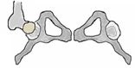
A similar experimental and computational protocol was used on two separate cadaveric hip joints.
Load
Figure 1. Loading Apparatus.

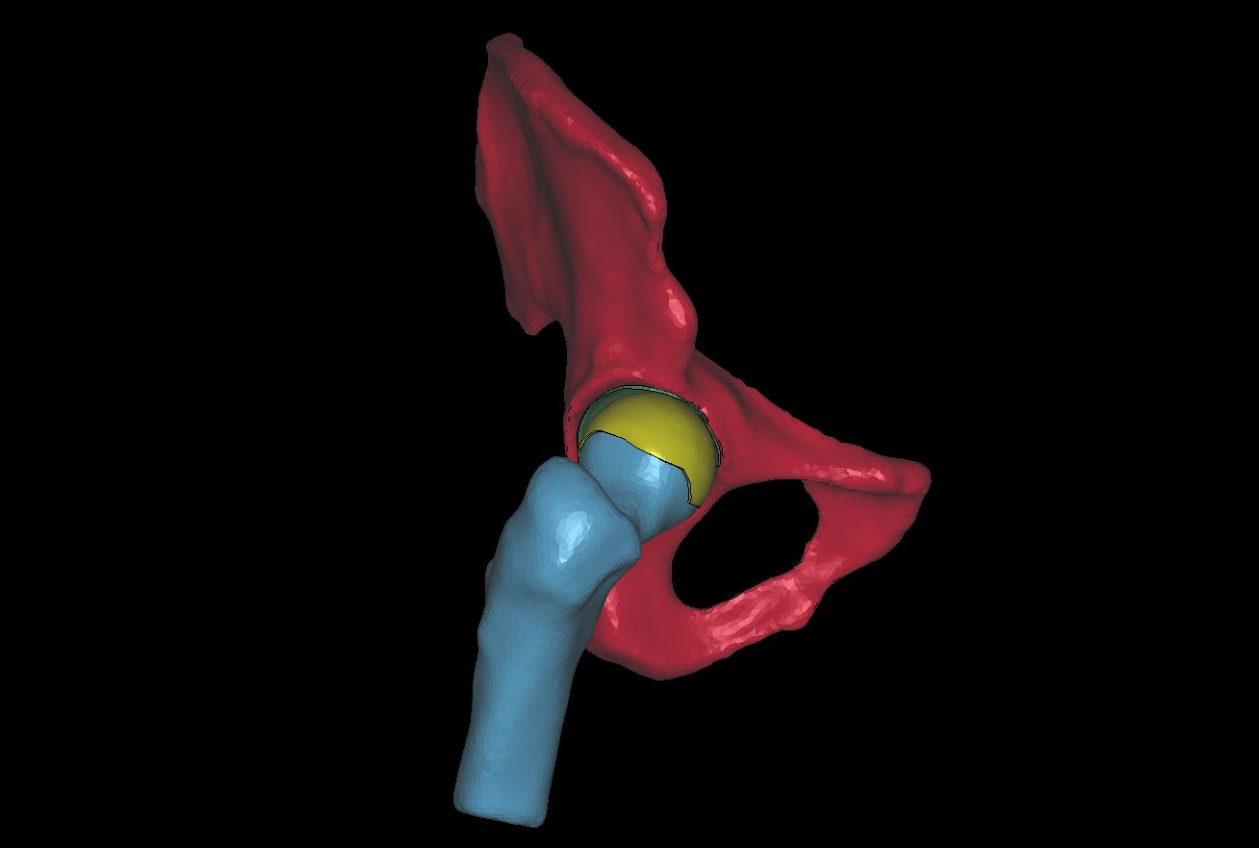
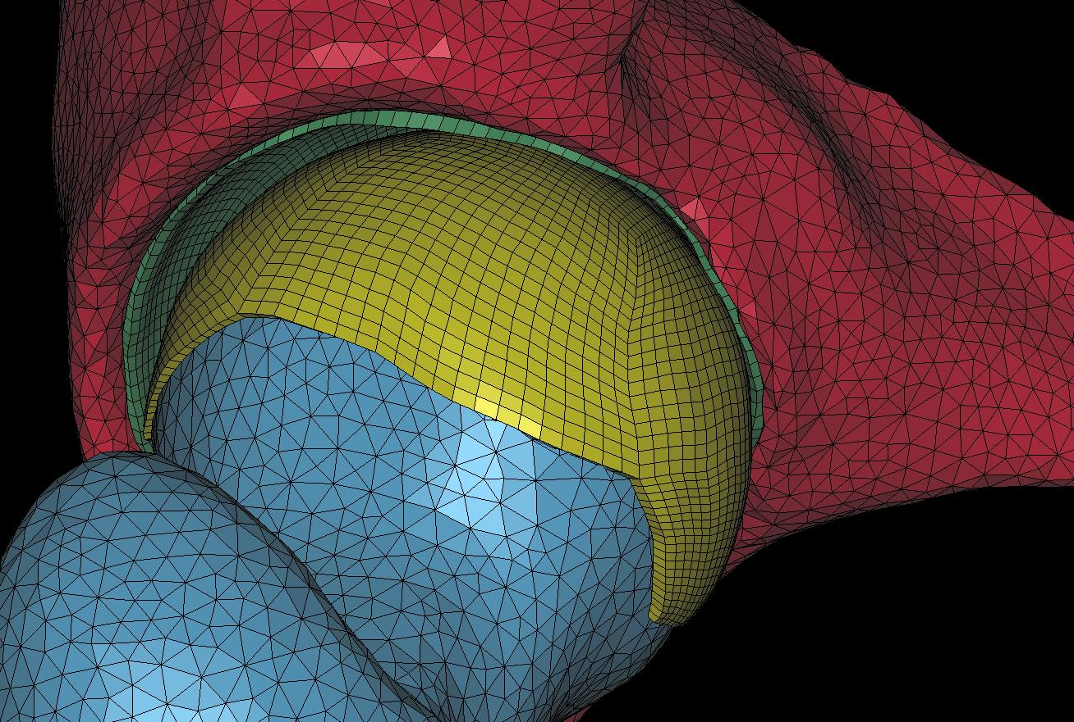
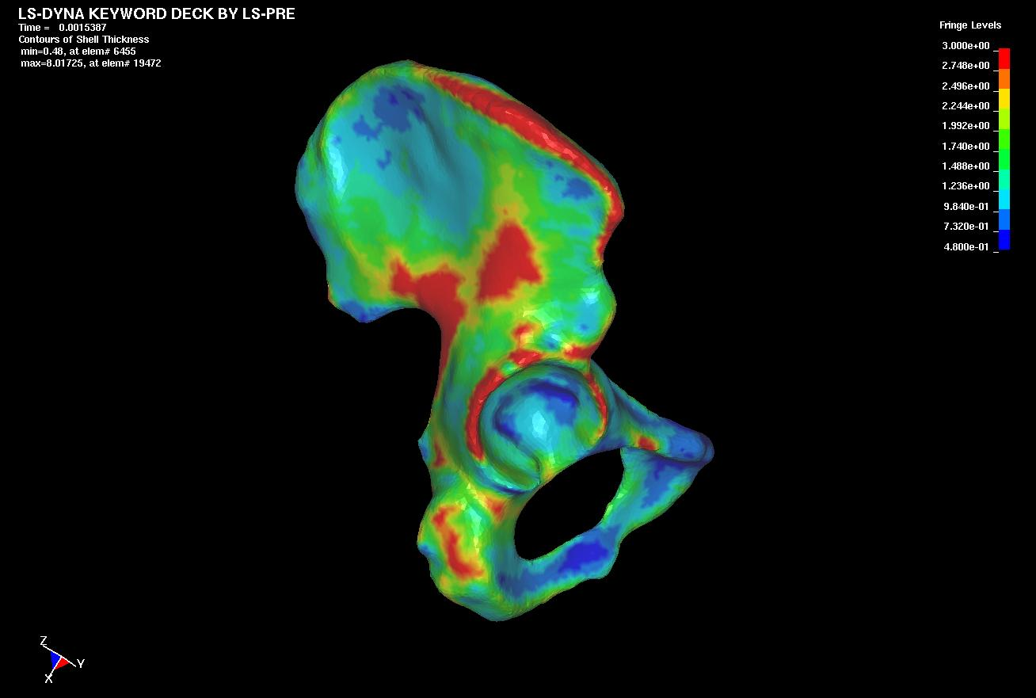
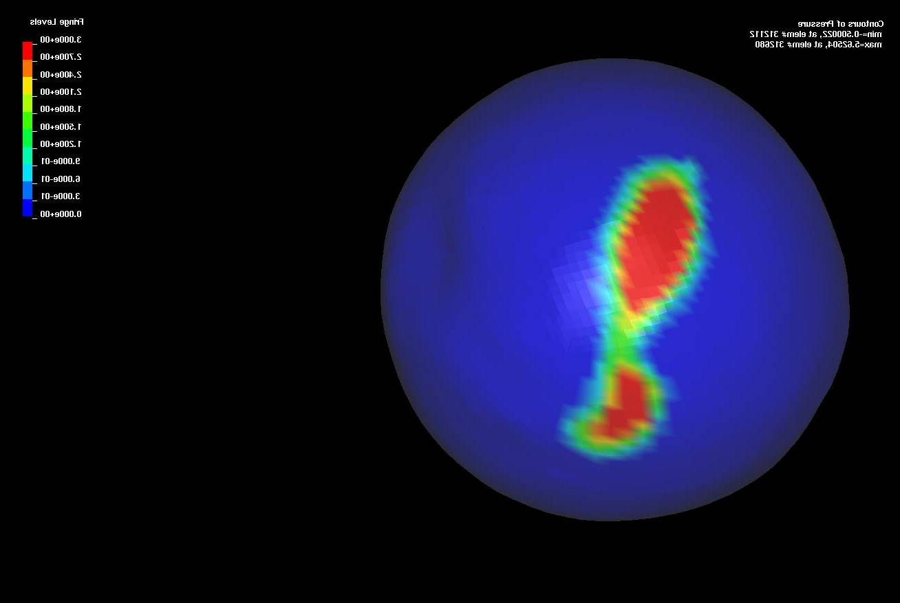
Experimental Setup/Loading. All soft tissue, with the exception of articular cartilage, was removed from both cadaveric hips. The iliac crests of each pelvis were mounted in a pan of catalyzed polymer resin (Fig. 1) [1]. The hemipelvis of one specimen was instrumented with 10 tri-axial strain gauges (Vishay Measurements Group), at locations around the acetabulum, pubis, ischium, and ilium. The femoral head of the second specimen was fitted with super-low pressure film (0 - 3 MPa, Sensor Products Inc.) for assessment of cartilage contact stress. The film was cut into a rosette pattern [2] (Fig. 4) to prevent crinkle artifact. Kinematic blocks were attached to the pelvis and femur/prosthesis for spatial registration between experimental and FE coordinate systems.
3 mm
0 mm
Figure 2. Left) position dependent thickness in the pelvis. Right) hip joint FE mesh with close-up showing elements.

Both pelvi were loaded through the acetabulum via a linear actuator (Fig. 1). A prosthetic femur was used to apply vertically oriented loads (0.25, 0.50, 0.75, and 1.0 X BW) to the acetabulum of the pelvis instrumented with strain gauges. A 1 X BW load was applied to the other pelvis in a similar fashion using the proximal third of the corresponding cadaveric femur. 3-D coordinates of the strain gauges, registration blocks, iliac cement depth line and anatomical reference points on the surface of the pressure film were determined using an electromagnetic digitizer (Immersion Corp.). Strain gauge data were converted to minimum and maximum in-plane principal strains. The pressure film was scanned and converted to a raster image. The resulting pixel values were scaled to pressures using an independent calibration curve and converted into a color fringe output.

Computational Analyses. A volumetric CT scan (512x512 acq. matrix, slice thickness=0.6 mm) was obtained in a superior to inferior fashion for each cadaveric hip. A solid mineral phantom (Kyoto Kagaku) was also imaged to correlate CT intensities to equivalent calcium density. Separate surfaces for the outer cortex and the boundary of the cortical and trabecular bone were extracted from the CT data. The cortical and trabecular bone were defined as triangular shell and tetrahedral solid elements, respectively (Fig. 2). A spatially varying cortical shell thickness was assigned to the shell elements based on the distances between the two polygonal surfaces (Fig. 2). Acetabular cartilage was represented with shell elements at a constant thickness of 2 mm for the pelvis instrumented with strain gauges. Cartilage geometry was segmented separately from the CT image data of the cadaveric hip used to measure contact pressures. The cartilage surfaces were imported into Truegrid (XYZ Scientific) for hexahedral mesh generation (Fig. 2).
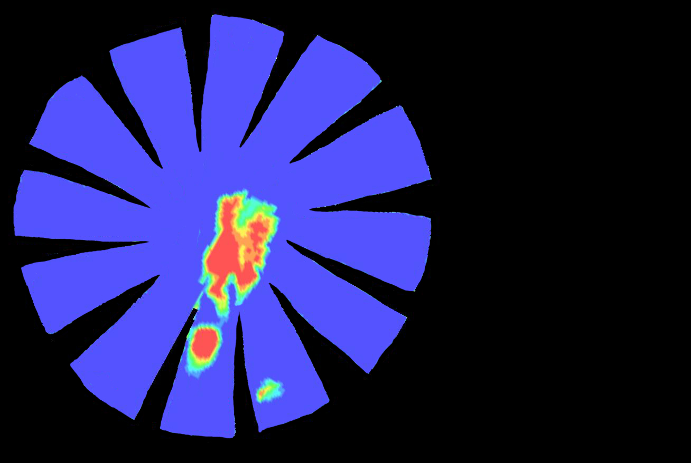
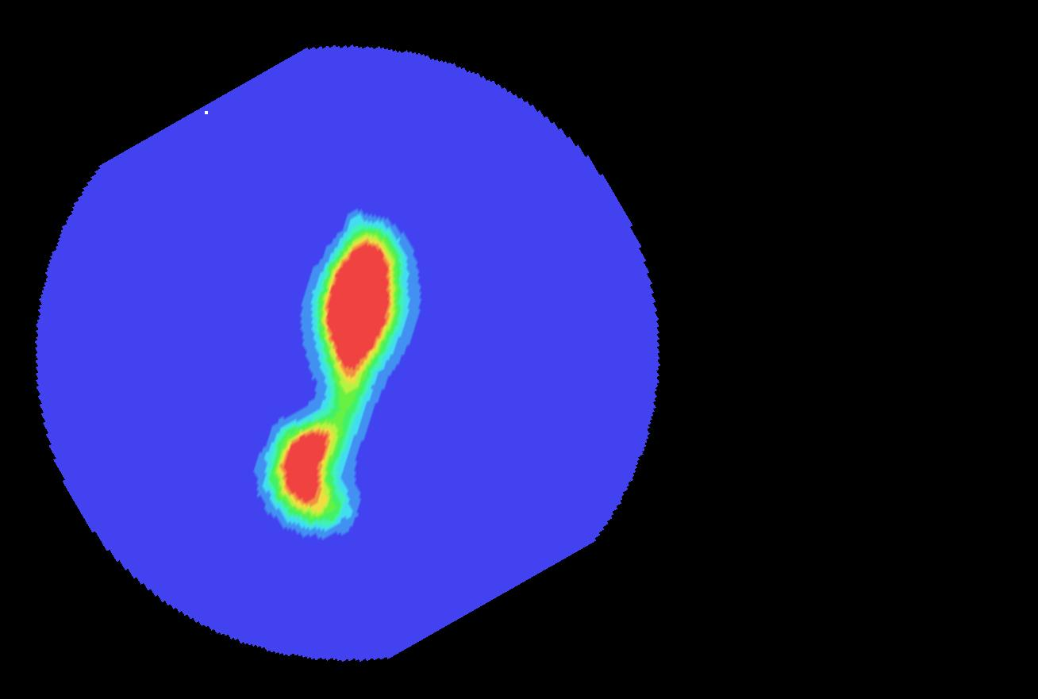
Cortical and trabecular bone were represented as isotropic elastic. Material properties for cortical bone were E=17 GPa and ν=0.29 [1]. Elements representing trabecular bone were assigned a location dependent modulus using an empirical relationship between calcium equivalent density and elastic modulus [3]. Cartilage is a biphasic material; however, contact stress measurements with pressure film yield the total stress at the instant of contact, which are equivalent to the contact stress from an incompressible elastic analysis [4]. Therefore, cartilage was represented as an isotropic elastic material with material properties: E=15 MPa, ν=0.475 [5]. The femoral implant was modeled as rigid for the model investigating cortical strain distribution. Nodes superior to the cement depth line and along the pubis joint were constrained. Frictionless contact was enforced between the femoral implant/femur and cartilage. All analyses were performed with the implicit capabilities of LS-DYNA (Livermore Software Technology Corp.). FE predictions of cortical principal strains were averaged over elements beneath each strain gauge. An algorithm was developed to convert 3-D FE pressures to a 2-D synthetic image for comparison with pressure images. Digitized anatomical points aligned the synthetic image with the experimental test results.
Posterior
Lateral
Medial
0 MPa
3 MPa
Experimental
FE
Anterior
Figure 4. Left) pressure film contact stress. Right) flattened FE predictions of contact stress.

Sensitivity studies were performed to assess the effects of assumed and estimated material parameters (cortical thickness, tissue moduli, and Poisson’s ratio) on cortical surface strains. An additional sensitivity model assessed changes in the location of cartilage contact and peak pressures when both bones were assumed rigid.

RESULTS
Cortical Bone Strains. The subject-specific FE model predictions of principal strains (Fig. 3) were strongly correlated with experimental measurements, with a best-fit line that was not statistically different than the line y = x (Exp. strain = FE strain).
Sensitivity models demonstrated that FE bone strain predictions were very sensitive to alterations in cortical bone thickness and cortical bone elastic modulus; all other parameters did not have a significant effect on bone strains (data not shown). On average, cortical strains were 20 times more sensitive to changes in cortical bone modulus than to alterations in the trabecular bone modulus.
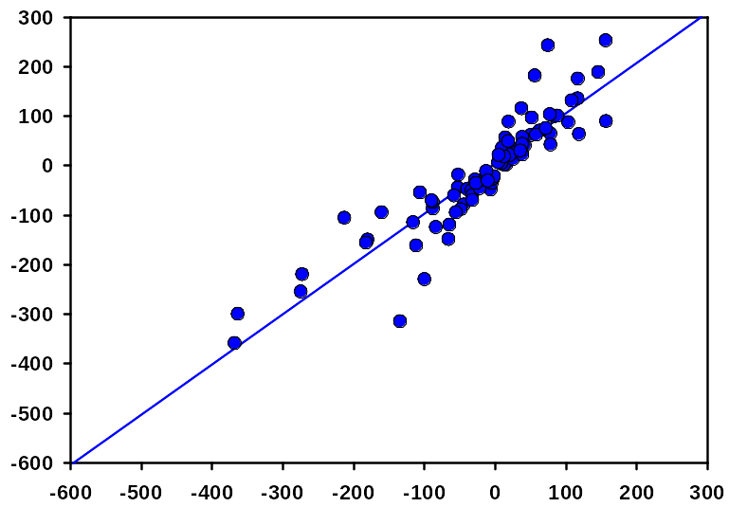
FE Min/Max Prin. Strain (μstrain)
Exp. Min/Max Prin. Strain (μstrain)
Figure 3. FE predicted vs. experimental bone strains.

R² =0.82
slope = 1.01
y-int. = 4.71
Cartilage Contact Stress. Experimental contact pressures ranged from 0 - 3 MPa (upper limit of film detection). The magnitude (0 - 5.5 MPa) and spatial distribution of FE predicted contact pressures were in excellent agreement with experimental results. Two distinct contact patterns were present in both the experimental pressure images and the FE model fringe plot (Fig. 4). The pattern of contact for the rigid bone sensitivity model was noticeably different than the deformable FE model. Peak contact pressure was 43% higher than the original FE model.

DISCUSSION
This research examined the ability of subject-specific FE models of the human hip to predict pelvic cortical bone strains and cartilage contact stresses. Accurate FE predictions of both bone strain and cartilage contact stress were obtained. Cortical bone strains were very sensitive to changes in cortical thickness and modulus, which suggests that accurate estimations of these parameters are important. Bones should be modeled as deformable structures for joint contact models of the hip, since both the location of cartilage contact and pressure magnitude are significantly altered when bones are assumed rigid.
The techniques and results of this study will provide the basis for future efforts to analyze patient-specific FE models of the pelvis to elucidate the biomechanics of hip dysplasia and total hip reconstruction.

acknowledgements
University of Utah Seed Grant, Orthopedic Research and Education Foundation Research Grant.

References
1. Dalstra, M., Huiskes, R., and van Erning, L., 1995, "Development and validation of a three-dimensional finite element model of the pelvic bone", J Biomech Eng, Vol. 117, pp. 272-8.
2. von Eisenhart-Rothe, R., Eckstein, F., Muller-Gerbl, M., Landgraf, J., Rock, C., and Putz, R., 1997, "Direct comparison of contact areas, contact stress and subchondral mineralization in human hip joint specimens", Anat Embryol (Berl), Vol. 195, pp. 279-88.
3. Dalstra, M., Huiskes, R., Odgaard, A., and van Erning, L., 1993, "Mechanical and textural properties of pelvic trabecular bone", J Biomech, Vol. 26, pp. 523-35.
4. Ateshian, G. A., Lai, W. M., Zhu, W. B., and Mow, V. C., 1994, "An asymptotic solution for the contact of two biphasic cartilage layers", J Biomech, Vol. 27, pp. 1347-60.
5. Shepherd, D. E. and Seedhom, B. B., 1999, "The 'instantaneous' compressive modulus of human articular cartilage in joints of the lower limb", Rheumatology (Oxford), Vol. 38, pp. 124-32.

